

**CSYE7105**

**PARALLEL MACHINE LEARNING AND AI**

**Project Topic:**

**Deep-fake Detection**



Team-5

Team Member:

RAKESH CHOUDHURY

# 

# Introduction

## What are deepfakes?

Deepfake techniques, which present realistic AI-generated videos of people doing and saying fictional things, have the potential to have a significant impact on how people determine the legitimacy of information presented online. These content generation and modification technologies may affect the quality of public discourse and the safeguarding of human rights—especially given that deepfakes may be used maliciously as a source of misinformation, manipulation, harassment, and persuasion. Identifying manipulated media is a technically demanding and rapidly evolving challenge.

Generating deepfakes are generated using GANs (Generative Adversarial Networks) and sophisticated Technologies and techniques for machine learning and artificial intelligence to manipulate the content with high potential to deceive. It is basically someone else's face or any celebrity's face so that it looks like the person who is talking with someone else’s face. Deepfakes have caught the attention of many people about using deepfake on celebrities and many famous people and creating hoax in the news.

Deepfakes rely on a type of [neural network](https://en.wikipedia.org/wiki/Artificial_neural_network) called an [autoencoder](https://en.wikipedia.org/wiki/Autoencoder). These consist of an encoder, which reduces an image to a lower dimensional latent space, and a decoder, which reconstructs the image from the latent representation. Deepfakes utilize this architecture by having a universal encoder which encodes a person into the latent space.The latent representation contains key features about their facial features and body posture. This can then be decoded with a model trained specifically for the target. This means the target's detailed information will be superimposed on the underlying facial and body features of the original video, represented in the latent space.

## Effects of deepfake in the real world.

The politics have been affected the most by the deepfake because any politician's face can morph to any notorious person and a chain of fake news can be propagated throughout the social network and social media. For example In January 2019, [Fox](https://en.wikipedia.org/wiki/Fox_Broadcasting_Company) affiliate [KCPQ](https://en.wikipedia.org/wiki/KCPQ) aired a deepfake of Trump during [his Oval Office address](https://en.wikipedia.org/wiki/January_2019_Oval_Office_address), mocking his appearance and skin color (and subsequently fired an employee found responsible for the video).

A deepfake of Donald Trump was easily created based on a skit Jimmy Fallon performed on NBC's The Tonight Show. In this skit (aired 4 May 2016), Jimmy Fallon dressed up as Donald Trump and pretended to participate in a phone call with Barack Obama, conversing in a manner that presented him to be bragging about his primary win in Indiana.

American actor Jordan Peele, BuzzFeed, and Monkeypaw Productions created and produced a deepfake of Barack Obama (uploaded to YouTube on 17 Apr 2018) that depicted Barack Obama cursing and calling Donald Trump names. In this deepfake Peele's voice and mouth was transformed and manipulated into Obama's voice and face. The intent for this video was to portray the dangerous consequences and power of deepfakes, and how deepfakes can make anyone say anything.

However, it made a positive impact on the movie industry like Disney where they have improved their visual effects using high resolution deepfake face swapping technology. Disney improved their technology through progressive training programmed to identify facial expressions, implementing a face swapping feature, and iterating in order to stabilize and refine the output. This high resolution deepfake technology will be implemented into movie and television production—saving significant operational and production costs. Disney's deepfake generation model can produce AI-generated media at a 1024 x 1024 resolution, which is much greater and produces more realistic results than common models that produce media at a 256 x 256 resolution. In addition, with this technology, Disney has the opportunity to revive dead actors and characters with a quick and simple face swap; Disney can now resurrect and revive characters for fans to enjoy.

It also has created positive values in the corporate world where corporate training videos can be created using deepfaked avatars and their voices. An example of this is Synthesia, which uses deepfake technology with avatars to create personalized videos. Microsoft has developed an app called "Seeing AI" which uses artificial intelligence and deepfake technology to narrate the world around you to aid individuals who are blind and/or have low vision. With deepfake technology, this app can narrate text in documents, scan products and barcodes, recognize people and their emotions, describe the location and setting around you, identify currency and bills, and communicate these features in different languages in a volume and tone that is adjusted to your surroundings.

## How Dangerous are deepfakes?

The fake news perceived by the people all over the country can lead to ramifications. This makes a lot of people nervous, so much so that Marco Rubio, the Republican senator from Florida and 2016 presidential candidate, called them the modern equivalent of nuclear weapons. "In the old days," he told an audience in Washington a couple weeks ago, "if you wanted to threaten the United States, you needed 10 aircraft carriers, and nuclear weapons, and long-range missiles. Today, you just need access to our internet system, to our banking system, to our electrical grid and infrastructure, and increasingly, all you need is the ability to produce a very realistic fake video that could undermine our elections, that could throw our country into tremendous crisis internally and weaken us deeply."

Political hyperbole skewed by frustrated ambition, or are deepfakes really a bigger threat than nuclear weapons? To hear Rubio tell it, we're headed for Armageddon. Not everyone agrees, however.

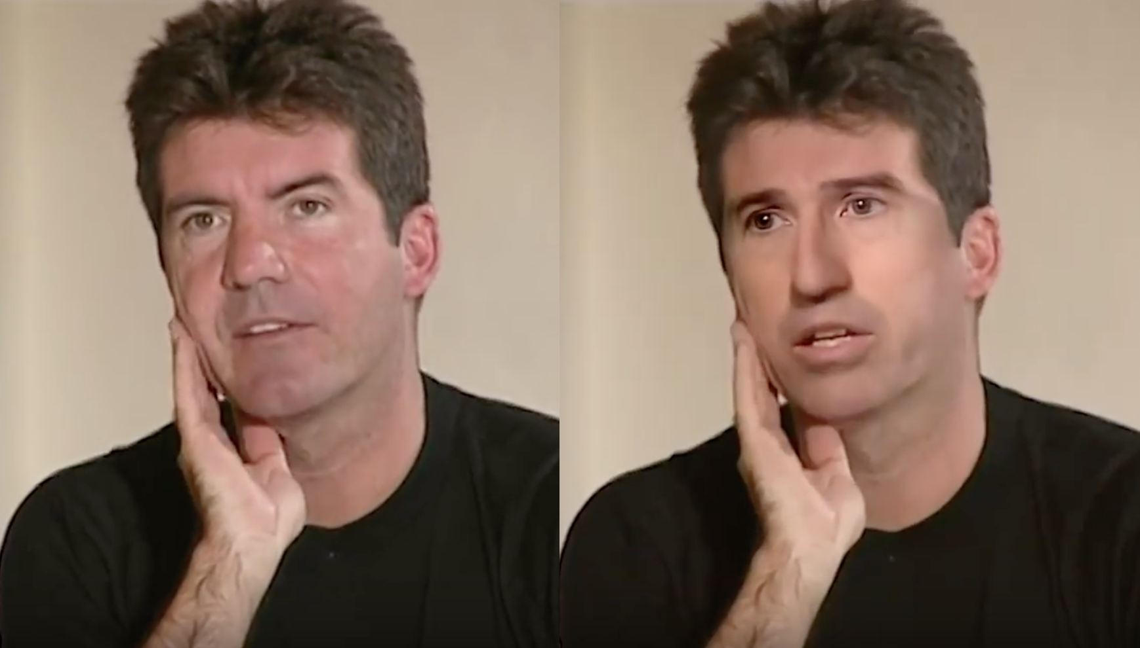

Left is real and right is fake

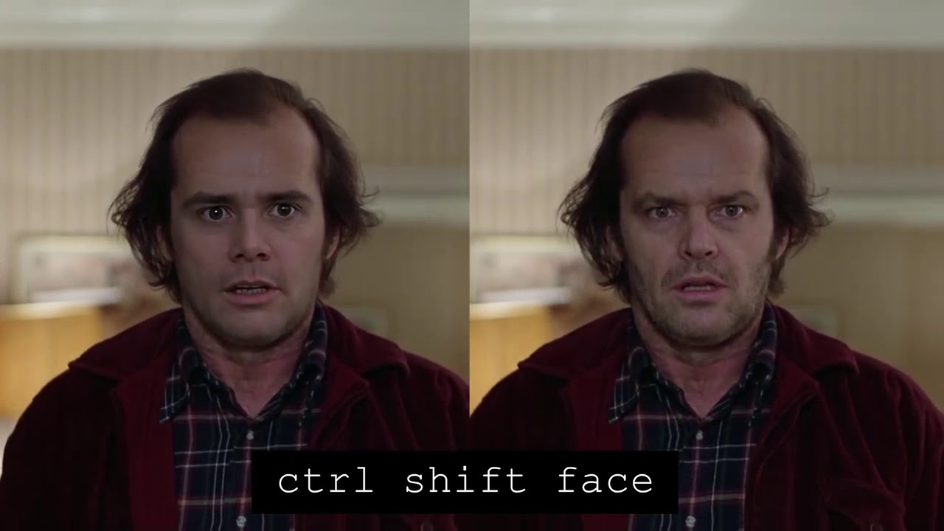

Left is fake and the right is real.

## Steps taken to overcome deepfake.

Microsoft has created an application tool that detects the deepfake in real time. So in the tool the video Authenticator can analyze a still photo or video to provide a percentage chance, or confidence score, that the media is artificially manipulated. In the case of a video, it can provide this percentage in real-time on each frame as the video plays. It works by detecting the blending boundary of the deepfake and subtle fading or greyscale elements that might not be detectable by the human eye.

This technology was originally developed by Microsoft Research in coordination with Microsoft’s Responsible AI team and the Microsoft AI, Ethics and Effects in Engineering and Research (AETHER) Committee, which is an advisory board at Microsoft that helps to ensure that new technology is developed and fielded in a responsible manner. Video Authenticator was created using a public dataset from Face Forensic++ and was tested on the DeepFake Detection Challenge Dataset, both leading models for training and testing deepfake detection technologies.

# Methodology

## How does deepfake detection work?

How do you spot a DeepFake? How good are DeepFake videos? How well can ordinary people tell the difference between a video manipulated by AI and a normal, non-altered video? Rather than try to explain in words, I have built a machine learning model with pytorch extensively to capture different frames from the video and rate the video with a probability score .It turns out there are many subtle signs that a video has been algorithmically manipulated.

It is hypothesised that the exposure of how DeepFakes look and the experience of detecting subtle computational manipulations will increase people's ability to discern a wide-range of video manipulations in the future.

## Workflow

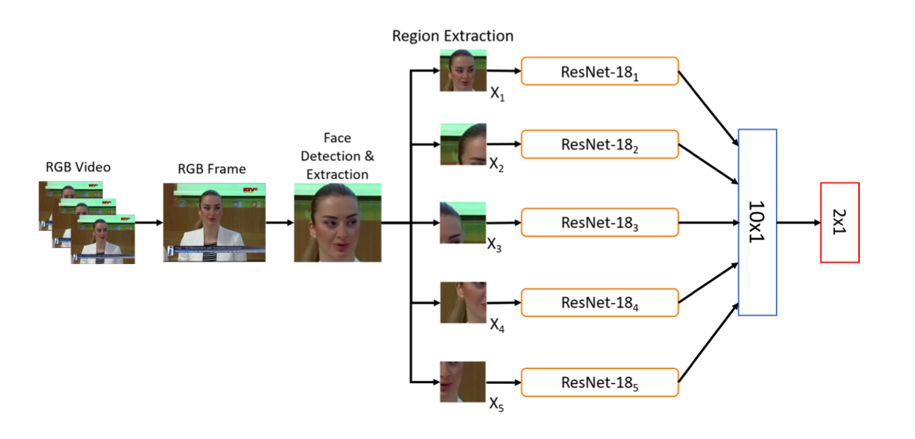

The OpenCV library is used for extracting faces from each frame produced in the video and the different features of the face are extracted and fed into the model to finally classify whether the video is fake or real.

## Libraries overview

In this project the first thing that is used is the face detection where the blaze face library is used for detecting the face. The face detection library is a combination of blaze face and mediapipe for detecting the face so that the algorithm runs on all platforms. Blaze face is a lightweight and well-performing face detector tailored for mobile GPU inference. It runs at a speed of 200–1000+ FPS on flagship devices. This super-realtime performance enables it to be applied to any augmented reality pipeline that requires an accurate facial region of interest as an input for task-specific models, such as 2D/3D facial keypoint or geometry estimation, facial features or expression classification, and face region segmentation. Our contributions include a lightweight feature extraction network inspired by, but distinct from MobileNetV1/V2, a GPU-friendly anchor scheme modified from Single Shot MultiBox Detector (SSD), and an improved tie resolution strategy alternative to non-maximum suppression.

MediaPipe on the Web is an effort to run the same ML solutions built for mobile and desktop also in web browsers. The official API is under construction, but the core technology has been proven effective. In order to have effective face detection the opencv library was also used which were embedded in the above two libraries.

The following shows how those libraries detect the face and check the face lines from the video in order to keep the track of facial movements.

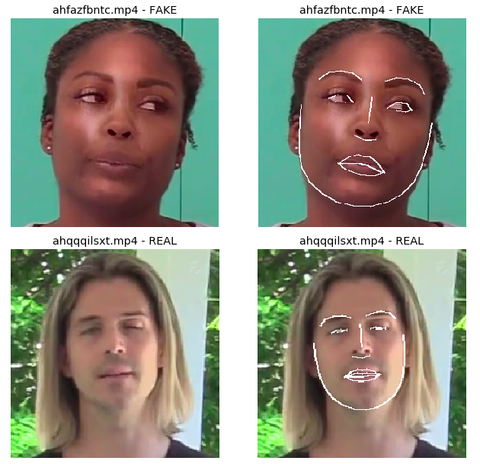

The above picture shows the data from the trained model how it draws the line along the face edges to capture every frame.

## Know about pytorch

PyTorch is an open source machine learning library based on the [Torch](https://en.wikipedia.org/wiki/Torch_(machine_learning)) library used for applications such as computer vision and natural language processing, primarily developed by Facebook's AI Research lab (FAIR). It is free and open-source software released under the Modified BSD license. Although the [Python](https://en.wikipedia.org/wiki/Python_(programming_language)) interface is more polished and the primary focus of development, PyTorch also has a C++ interface.

PyTorch is a Python package that provides two high-level features:

* Tensor computation (like NumPy) with strong GPU acceleration
* Deep neural networks built on a tape-based autograd system

We can reuse our favorite Python packages such as NumPy, SciPy, and Cython to extend PyTorch when needed.

In this project torch and torch.nn are used extensively for parallel processing and image processing. Torch is a Tensor library like NumPy, with strong GPU support. Torch.nn is a neural networks library deeply integrated with autograd designed for maximum flexibility. PyTorch provides Tensors that can live either on the CPU or the GPU and accelerates the computation by a huge amount. The pytorch helps the python code to run on GPUs and helps to save time and money.

## Setting up the environment

This whole project is run in the pytorch environment that was created using anaconda CLI(Command Line Interface). So as to setup the environment we need to install the pytorch, so the steps as follows:

First you need to load the cuda module

module load cuda/11.0

Second load anaconda module

module load anaconda3/3.7

Third install the pytorch environment

conda create --name pytorch_env python=3.7 anaconda

Lastly activate the python environment

conda activate pytorch_env

Finally run the command below to install the pytorch



Since the cluster runs on linux so the above command can be run to install the pytorch

In order to check if you are in the GPU node you can run the following command:

python

torch.cuda.is_available()

If the output is true then you are in the GPU node.

## Other libraries and dependencies installation

Before we move forward with running the python script we need to install a couple of dependency files and libraries so that the code runs without errors.

Install the efficientnet-pytorch package

pip install --upgrade efficientnet-pytorch

pip install input/EfficientNet-PyTorch-master > /dev/null

Make sure you define the path to the folder EfficientNet-PyTorch-master correctly in my case the folder is placed inside the input folder.

There are other image processing libraries that need to be installed:

Installing OpenCV

pip install opencv-contrib-python

Installing Tensorflow

# Current stable release for CPU and GPU

pip install tensorflow

This project also contains the neural network files as .pt extensions in kdold_deep-fake_effb2 and kdold_deep-fake_effb2_flip folders whose path is defined in the below code snippet.

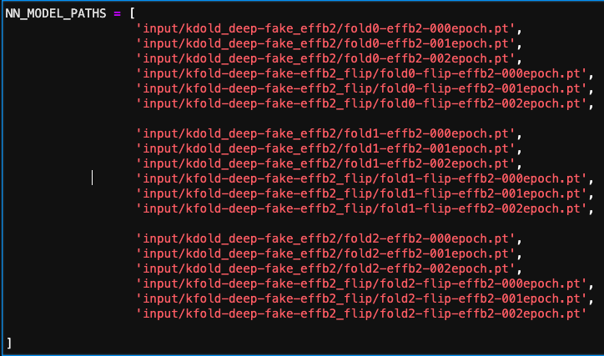

Make sure to define your path as per your system folder’s configuration.

## Video data preparation

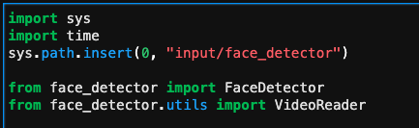

The code begins with using the face detection, so here sys library is imported because the face detector library is in the local system. The library is customised to process the video as well to capture the face from different frames.

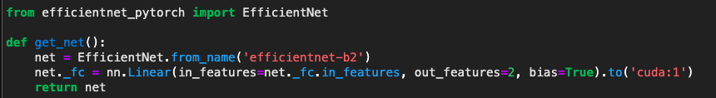

Before importing the library make sure this particular library efficientnet_pytorch is updated. This function extracts the feature from the face and it runs on the GPU node “cuda:1”.

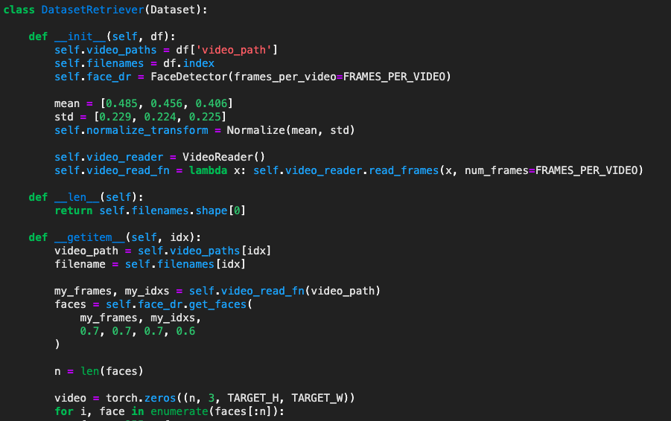

The class data retriever is created to capture different frames from the video and forms a transformation matrix to train the model and do further calculations. Later on the function it captures a certain number of frames from a big chucks of frames captured initially. The next function captures the face from those frames and stores it in a video along with the filenames.

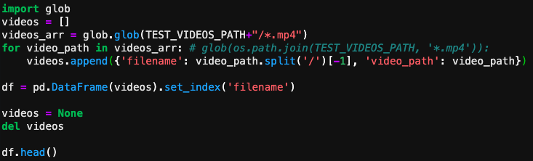

Here the code basically creates the pandas dataframe which stores the video filename and its corresponding path. So following the code it first takes the file path name and splits it into file path and video name present in the path name. Consequently it then creates the pandas dataframe with two columns, one for the file path name and the other for video file name.

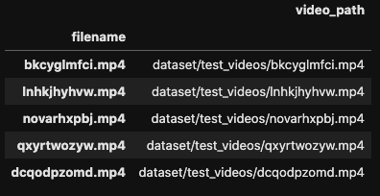

In order to check if the dataretriever classes work correctly here is the small test code snippet below that shows a face from the video captured and plotted over the graph using only RGB(Red Green Blue). As we can see it also captures the face even though the person is looking away from the camera.

## 

## Running the neural networks

For running the neural network a class deepfake predictor is created which contains different functions as follows:

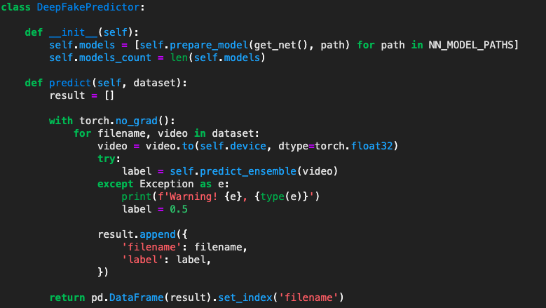

The predict function gives a score to each video depending on whether it is fake or real the score mainly ranges from 0 to 1 which is mostly calculation of probabilities. Sometimes the model might not be able to predict whether it's fake or real, so for that exception handling is implemented where it checks for the warning message and gives that video a score of 0.5 which would neither be categorised as real or fake.

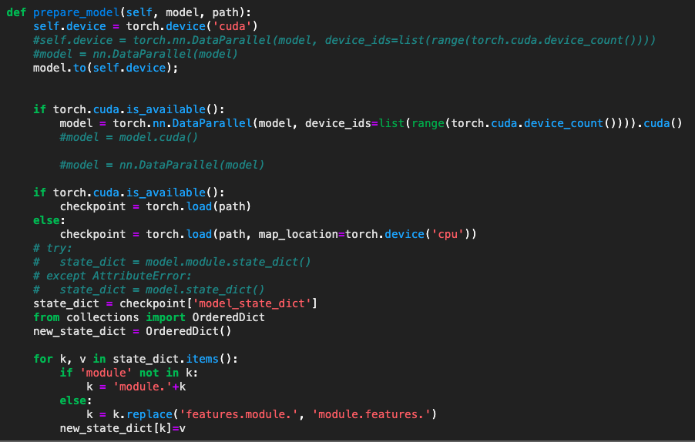

The above function is for preparing the model on GPU. So ‘cuda’ is the selected device in the code which will be used to prepare the model. This function will run in parallel using the DataParallel function where it takes a chunk of data to process them on all the available GPUs in the cluster. All features and parameters are configured to be trained on the dataset.

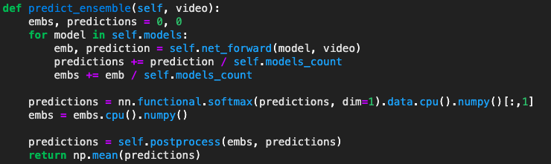

The function above calculates the matrix from the model and normalizes it so as to get a better prediction score for each video.

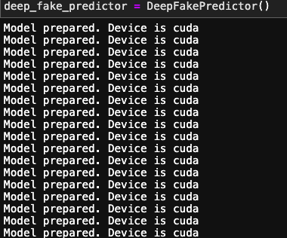

When the model is finally prepared it runs on the GPU nodes.

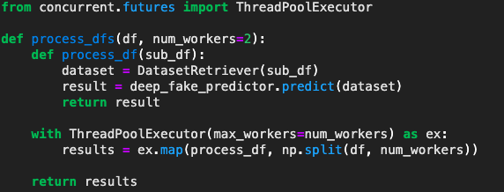

This function above then gets the video from the dataset and runs the deepfake predictor over it in order to give a score to the video from 0 to 1 depending on how fake or real the video is. 0 score being the lowest which means video is real and 1 being the highest which means the video mostly involves deepfake.

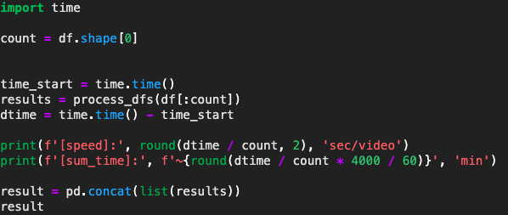

Here the training of the model starts and the time for running the model is calculated in order to track the performance of the cluster for the code.

# Dataset Description

The dataset mostly consists of manipulated and real videos for the model to predict and assign it some score. The dataset size is 4GB which is collected from kaggle although the original dataset size was 470GB it has been listed as small chunks so that the system can take the load of the video data.

The data is composed of .mp4 files, split into compressed sets of ~10GB apiece. A metadata.json accompanies each set of .mp4 files, and contains filename, label (REAL/FAKE), original and split columns, listed below under Columns.

In this project the video is classified by predicting whether or not a particular video is a deepfake. A deepfake could be either a face or voice swap (or both). In the training data, this is denoted by the string "REAL" or "FAKE" in the label column.

## Files

* train_sample_videos.zip - a ZIP file containing a sample set of training videos and a metadata.json with labels.
* sample_submission.csv - a sample submission file in the correct format.
* test_videos.zip - a zip file containing a small set of videos to be used as a public validation set.

## Columns in sample table

* filename - the filename of the video
* label - whether the video is REAL or FAKE
* original - in the case that a train set video is FAKE, the original video is listed here
* split - this is always equal to "train".

Dataset link: <https://drive.google.com/drive/folders/1ASJrtmqha0MVIuNg8Dtx6H8X1RWE0Le->

# Results and Analysis

While training the model with the training dataset the accuracy increases as the number of epochs grow. Which says that the model will be a good fit for the training dataset.

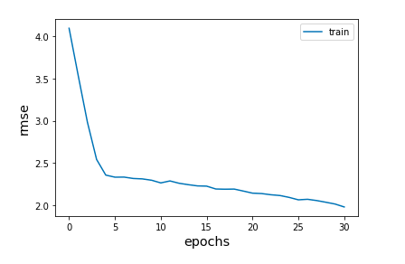

There are two sets of python file that needs to be run 1GPU and then in multiple GPU to see the time taken and discern its performance.

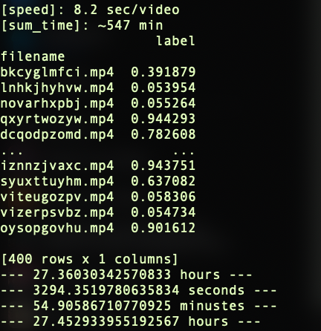

The above code is run serially and spends more time in processing time for each video that is 8.47 sec/video. This looks like the processing time is more for the serial code.

The result shows the prediction scores from 0 to 1 for each video file where the 0 is for most real video and 1 is for the most fake video. There were 400 rows being fetched which means we had 400 videos in our training dataset.

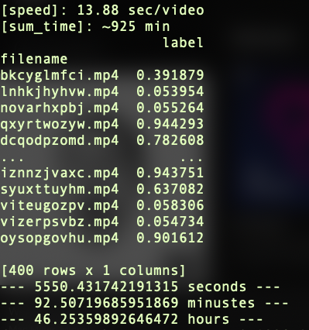

The above code is run serially and spends less time in processing for each video that is 2.4 sec/video. It shows that the code is run in parallel in multiple GPUs which also calculates on how much time of the process is spent on each video by the process.

Data Parallelism is when we split the mini-batch of samples into multiple smaller mini-batches and run the computation for each of the smaller mini-batches in parallel.

Data Parallelism is implemented using torch.nn.DataParallel. One can wrap a Module in DataParallel and it will be parallelized over multiple GPUs in the batch dimension.

# Conclusion

It can be concluded that the processing performance gets better when we have more GPUs to run our code. Data parallelism refers to using multiple GPUs to increase the number of chunks processed simultaneously. Model parallelism allows you to distribute different parts of the model across different devices. So model parallelism can be used to train models that requires more than one available GPU.

# References

* Wikipedia
* CSO United States
* MIT Media Lab
* Medium Articles
* Kaggle